**14. Perform Perspective Transformation on a video.**

**Aim:**

To perform perspective transformation on a video.

**Code:**

import cv2

import numpy as np

video_path = r"C:\\Users\\prith\\Documents\\CV\\cvVideo.mp4"

cap = cv2.VideoCapture(video_path)

if not cap.isOpened():

print("Error: Unable to open the video file")

exit()

ret, im_src = cap.read()

if not ret:

print("Error: Unable to read the video frame")

cap.release()

exit()

pts_src = np.array([[141, 131], [480, 159], [493, 630], [64, 601]])

pts_dst = np.array([[318, 256], [534, 372], [316, 670], [73, 473]])

im_dst = np.zeros_like(im_src)

h, status = cv2.findHomography(pts_src, pts_dst)

im_out = cv2.warpPerspective(im_src, h, (im_src.shape[1], im_src.shape[0]))

cv2.imshow("Source Image", im_src)

cv2.imshow("Destination Image", im_dst)

cv2.imshow("Warped Source Image", im_out)

cv2.waitKey(0)

cap.release()

cv2.destroyAllWindows()

**Input:**

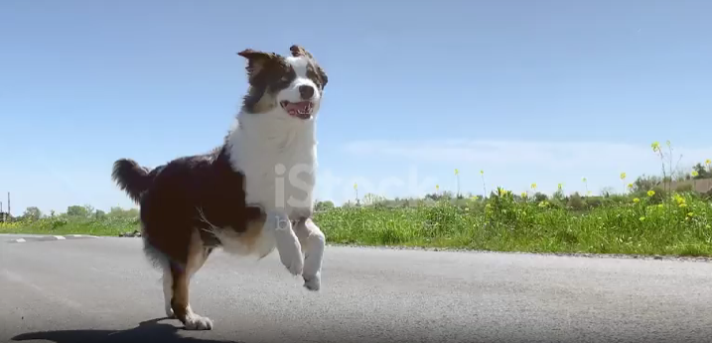

**Output:**

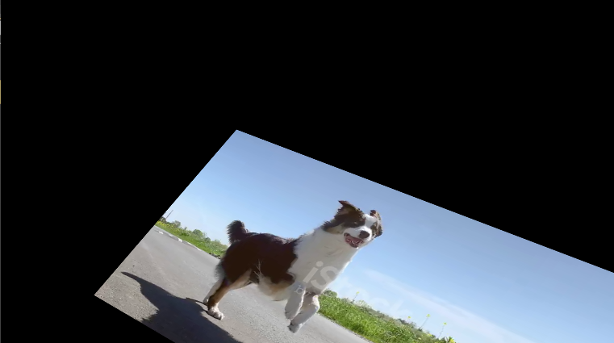

**Result:**

The python code to perform perspective transformation on an input video has been executed successfully.